SIMATS ENGINEERING
ASSIGNMENT
Department | Computer Science and Engineering
Programme | B.E./B.Tech. – Computer Science and Engineering
Course Code & Course Name | CSA11 – Object Oriented Analysis and Design
Academic Year / Batch | 2026–2027 / __________
Faculty Name | Dr.A.Gayathri
Assignment Title | Object-Oriented Analysis and UML-Based Design of an AI-Enabled Disaster Resilience and Emergency Response Platform (AIDERP)
Date of Issue | 01.09.2026
Date of Submission | 03.09.2026
Maximum Marks | 100
Course Outcome(s) – CO | CO1, CO2, CO3
Bloom's Taxonomy Level | BL3 – Apply, BL4 – Analyse, BL5 – Evaluate, BL6 – Create
SDG Mapping | SDG 3 – Good Health and Well-being; SDG 9 – Industry, Innovation and Infrastructure; SDG 11 – Sustainable Cities and Communities; SDG 13 – Climate Action
Industry / Societal Relevance | Emergency management, public safety, resilient infrastructure, healthcare coordination, IoT-enabled monitoring, geospatial services and secure information systems.

Code of Conduct:
I __K.Divya(192511316)__ (Name / Reg. No.) certify that this submission is my original work and that I have adhered to the guidelines specified for this assessment. I understand that any violation of academic integrity rules will result in disciplinary action.
Signature of the student: __K.Divya _

B. Assignment Problem / Challenge
The objective of this assignment is to analyse and develop an Object-Oriented Analysis and Design model for an AI-Enabled Disaster Resilience and Emergency Response Platform (AIDERP).
The proposed platform is designed to support communities, emergency coordinators, hospitals, police and fire services, volunteers, utility teams and local administrators during different types of emergencies such as:
- Floods
- Cyclones
- Fires
- Earthquakes
- Heatwaves
- Other natural and man-made emergencies
The system integrates information from different sources including citizen reports, IoT sensors, weather feeds, emergency-service updates, geospatial information and infrastructure status.
An intelligent risk-analysis module analyses the severity and possible impact of an emergency and recommends appropriate response actions.
The platform provides role-based functionality for:
- Citizens
- Emergency operators
- Field responders
- Medical teams
- Volunteers
- Administrators
- Hospitals
- Shelters
- Utility teams
The assignment requires students to identify the system actors, objects, classes, attributes, methods and relationships and develop appropriate UML models.
The required UML models include:
- Use Case Diagram
- Class Diagram
- Sequence Diagram
- Activity Diagram
- State Transition Diagram
- Package Diagram
- Component Diagram
- Deployment Diagram
The design should demonstrate appropriate object-oriented principles and design patterns while achieving modularity, maintainability, reusability, scalability, security and resilience.

C. Problem Statement

Problem / Case / Design Challenge
During natural disasters and emergency situations, information is often collected from multiple sources and handled by different organizations. Lack of coordination, delayed information sharing, inaccurate reports and limited resource visibility can increase the impact of an emergency.
To address this problem, an AI-Enabled Disaster Resilience and Emergency Response Platform (AIDERP) is proposed.
The system shall collect and integrate information from:
- Citizen emergency reports
- IoT sensors
- Weather information
- Emergency-service updates
- Geospatial data
- Infrastructure status
The system shall analyse incoming information and identify the severity and priority of emergency incidents.
For example, when a flood sensor detects an abnormal water level, the system can create a preliminary incident. The risk-analysis module can analyse the situation along with population exposure, available resources and other information.
Citizens shall be able to:
- Report an emergency.
- Share their location.
- Request emergency assistance.
- Receive verified emergency alerts.
- Find nearby shelters.
- Obtain evacuation guidance.
- View recommended safe routes.
Emergency operators shall be able to:
- Validate reported incidents.
- Prioritize incidents.
- Coordinate response teams.
- Monitor available resources.
- Issue emergency alerts.
Field responders shall be able to:
- Receive assignments.
- Accept emergency tasks.
- Update incident status.
- Share field observations.
- Request additional resources.
Hospitals and shelters shall be able to:
- Update their capacity.
- Report availability.
- Provide information about available facilities.
The platform shall also use geospatial intelligence for:
- Incident mapping
- Safe-route identification
- Shelter selection
- Resource allocation
AI-based prioritization may consider:
- Incident severity
- Population exposure
- Accessibility
- Available resources
- Real-time sensor information
The AI system should act as a decision-support mechanism. Final emergency decisions should remain under authorized human supervision.

D. Requirements and Constraints

1. Functional Requirements
The system shall provide the following major functions:

FR1 – User Registration and Authentication
The system shall allow authorized users to register and securely access the platform based on their roles.

FR2 – Incident Reporting
Citizens shall be able to report emergency incidents by providing:
- Incident type
- Description
- Location
- Time
- Supporting information

FR3 – Incident Verification
Emergency operators shall verify reported incidents and distinguish between verified and unverified information.

FR4 – Risk Analysis
The system shall analyse emergency information and estimate incident severity and priority.

FR5 – Emergency Prioritization
The system shall prioritize incidents according to factors such as:
- Severity
- Population exposure
- Accessibility
- Resource availability
- Sensor information

FR6 – Emergency Team Dispatch
Emergency operators shall assign suitable response teams to incidents.

FR7 – Response Tracking
Field responders shall be able to update their progress, such as:
Assigned → Accepted → En Route → On Scene → Resolved

FR8 – Emergency Alerts
Authorized emergency operators shall be able to send verified alerts to affected citizens.

FR9 – Shelter Information
Citizens shall be able to identify nearby shelters and check their availability.

FR10 – Evacuation Guidance
The system shall provide evacuation guidance and recommend suitable safe routes.

FR11 – Resource Management
Emergency operators shall be able to monitor and allocate available resources.

FR12 – Hospital Capacity
Hospitals shall be able to update available beds, medical resources and emergency capacity.

FR13 – Shelter Capacity
Shelters shall be able to update their current occupancy and available capacity.

FR14 – IoT Sensor Integration
The platform shall receive information from sensors such as:
- Flood sensors
- Fire sensors
- Temperature sensors
- Air-quality sensors
- Structural sensors

FR15 – Geospatial Information
The system shall provide location-based services for:
- Incident mapping
- Safe routes
- Shelters
- Resources

FR16 – Incident Status Management
The system shall maintain the current status of every emergency incident.

FR17 – Administrator Functions
Administrators shall manage:
- Users
- Roles
- Access permissions
- System configuration
- System monitoring

2. Non-Functional Requirements

Performance
The system should process emergency information quickly and provide timely responses.

Availability
The system should remain available during emergency situations and infrastructure disruptions.

Security
The system shall implement authentication and authorization mechanisms.

Privacy
Sensitive citizen and emergency information shall be protected.

Reliability
The system should provide reliable emergency information and minimize incorrect data.

Scalability
The architecture should support increasing numbers of:
- Users
- Incidents
- Sensors
- Emergency teams
- Locations

Maintainability
The system should use modular object-oriented design to simplify maintenance.

Usability
The user interface should be easy to understand during stressful emergency situations.

Fault Tolerance
The system should continue providing essential services when some components fail.

Resilience
The platform should gracefully degrade during network or infrastructure failures.

E. Student Work

1. PROBLEM UNDERSTANDING AND FORMULATION

1.1 Problem Identification
The primary problem is the lack of a unified platform capable of collecting, analysing and coordinating emergency information from multiple sources.
Traditional emergency response systems may involve separate systems for citizens, emergency services, hospitals and shelters. This can result in:
- Delayed communication
- Duplicate information
- Poor resource coordination
- Difficulty verifying incidents
- Limited real-time visibility
- Inefficient emergency response
AIDERP addresses these problems by providing a centralized, object-oriented platform.

1.2 Expected Outcomes
The expected outcomes of the system are:
- Faster emergency reporting.
- Better incident verification.
- Intelligent incident prioritization.
- Improved emergency-team coordination.
- Better resource allocation.
- Faster communication with affected citizens.
- Improved shelter and hospital management.
- Better evacuation planning.
- Integration of IoT and geospatial information.
- Secure and scalable emergency management.

1.3 Major Stakeholders
The major stakeholders are:
- Citizens
- Emergency Operators
- Field Responders
- Hospitals
- Shelters
- Volunteers
- Police Services
- Fire Services
- Utility Teams
- Administrators
- IoT Sensor Systems
- Weather Information Systems

1.4 Assumptions
The following assumptions are considered:
- Users have appropriate authentication credentials.
- Emergency operators are authorized to verify incidents.
- IoT sensors provide data in a compatible format.
- Location information is available when required.
- Hospitals and shelters regularly update capacity.
- Emergency responders have access to the platform.
- AI recommendations are reviewed by authorized personnel.

2. APPLICATION OF COURSE KNOWLEDGE
The system applies several Object-Oriented Analysis and Design concepts.

2.1 Object Identification
Important objects include:
- User
- Citizen
- EmergencyOperator
- Responder
- Hospital
- Shelter
- Incident
- EmergencyAlert
- ResponseTeam
- Resource
- Sensor
- RiskAssessment
- Location
- EvacuationRoute
- Notification

2.2 Class Identification
Major classes include:

User
Attributes:
- userId
- name
- email
- phone
- password
- role
Methods:
- login()
- logout()
- updateProfile()

Citizen
Attributes:
- citizenId
- location
- emergencyStatus
Methods:
- reportIncident()
- requestAssistance()
- receiveAlert()
- findShelter()

EmergencyOperator
Attributes:
- operatorId
- department
- authorizationLevel
Methods:
- verifyIncident()
- prioritizeIncident()
- dispatchTeam()
- issueAlert()

Responder
Attributes:
- responderId
- teamId
- currentLocation
- status
Methods:
- acceptAssignment()
- updateStatus()
- shareObservation()
- requestResource()

Incident
Attributes:
- incidentId
- incidentType
- description
- location
- severity
- status
- timestamp
- verificationStatus
Methods:
- createIncident()
- updateIncident()
- verifyIncident()
- changeStatus()

RiskAssessment
Attributes:
- assessmentId
- severityScore
- exposureLevel
- priority
- recommendation
Methods:
- analyseRisk()
- calculatePriority()
- generateRecommendation()

Resource
Attributes:
- resourceId
- resourceType
- quantity
- availability
- location
Methods:
- allocate()
- release()
- checkAvailability()

Shelter
Attributes:
- shelterId
- name
- location
- capacity
- availableCapacity
Methods:
- updateCapacity()
- checkAvailability()

Hospital
Attributes:
- hospitalId
- name
- location
- bedCapacity
- availableBeds
Methods:
- updateCapacity()
- checkAvailability()

IoTSensor
Attributes:
- sensorId
- sensorType
- location
- status
- sensorValue
Methods:
- collectData()
- transmitData()
- detectAbnormalCondition()

2.3 Object-Oriented Principles

Encapsulation
Data and operations are grouped within classes. For example, the Incident class manages incident-related information and operations.

Abstraction
Complex processes such as AI risk analysis and route calculation are represented through simple operations while implementation details remain hidden.

Inheritance
Common properties can be inherited from a User class.
For example:
User → Citizen
User → EmergencyOperator
User → Responder
User → Administrator

Polymorphism
Different user roles can implement role-specific versions of common operations.
For example:
viewEmergencyInformation()
may behave differently for a Citizen, Responder and Administrator.

Cohesion
Each class should have a focused responsibility.

Coupling
Dependencies between classes should be minimized to improve maintainability.
3. SOLUTION / DESIGN / METHODOLOGY

3.1 Use Case Diagram
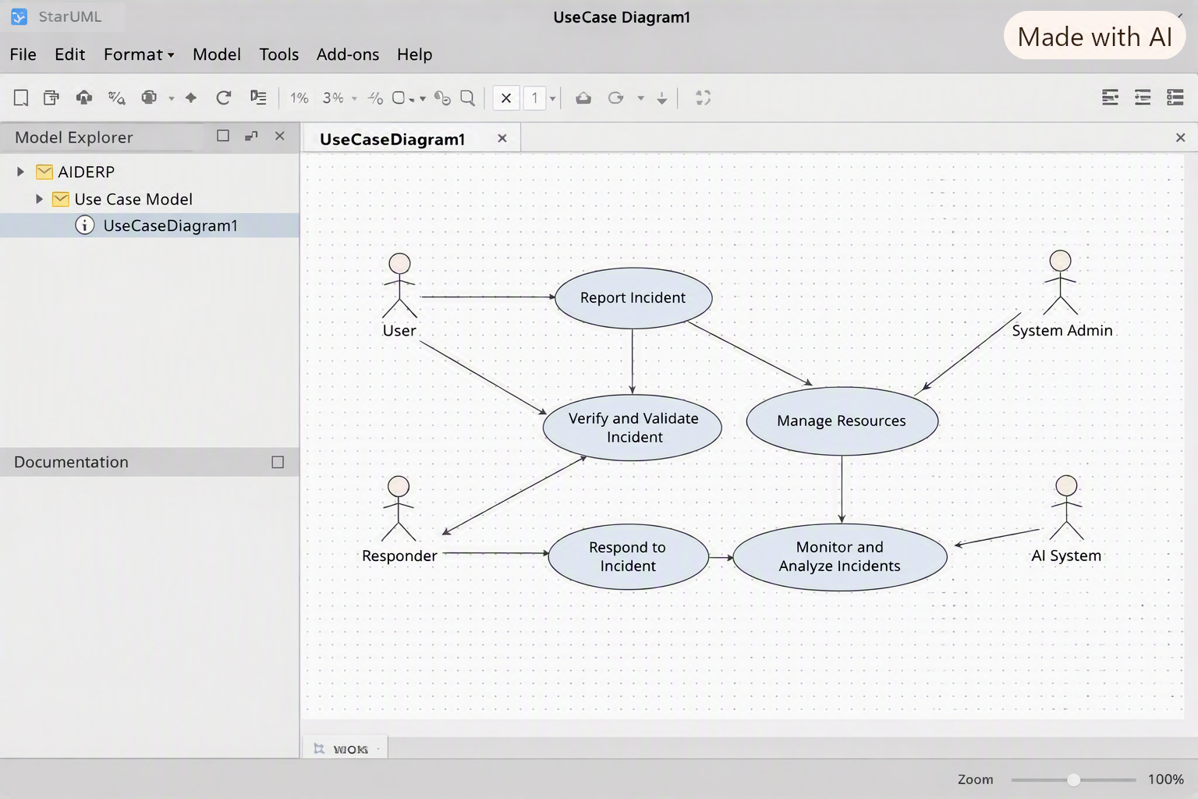
Figure 1: Use Case Diagram of AIDERP
Description: The Use Case Diagram represents the interactions between the AIDERP system and its major actors, including Citizens, Emergency Operators, Field Responders, Hospitals, Shelters and Administrators. It identifies the major services provided by the system, such as reporting emergencies, verifying incidents, dispatching response teams, updating incident status, managing resources and providing evacuation guidance.

3.2 Class Diagram
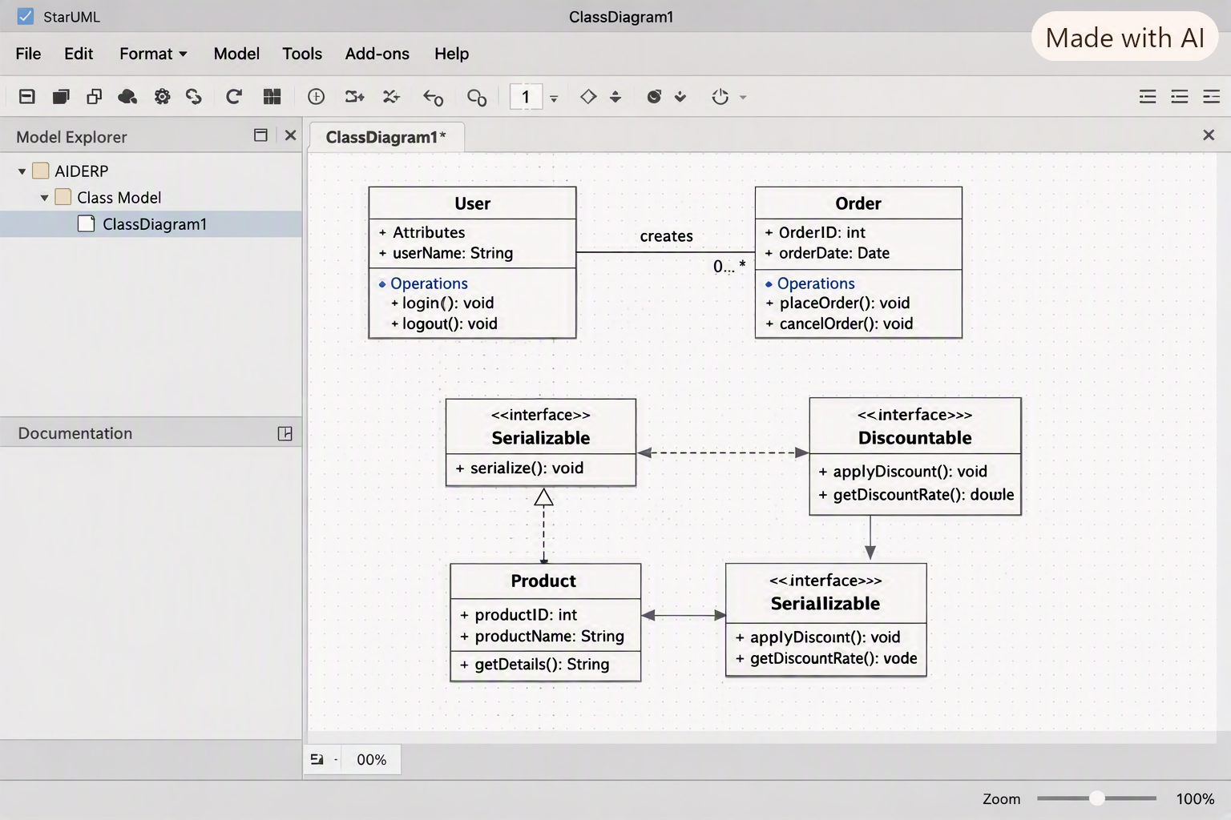
Figure 2: Class Diagram of AIDERP
Description: The Class Diagram represents the static structure of the AIDERP system. It identifies important classes such as User, Citizen, EmergencyOperator, Responder, Incident, RiskAssessment, ResponseTeam, Resource, Hospital, Shelter and IoTSensor. The diagram shows their attributes, methods and relationships and demonstrates object-oriented concepts such as inheritance, association, aggregation and dependency.

3.3 Sequence Diagram
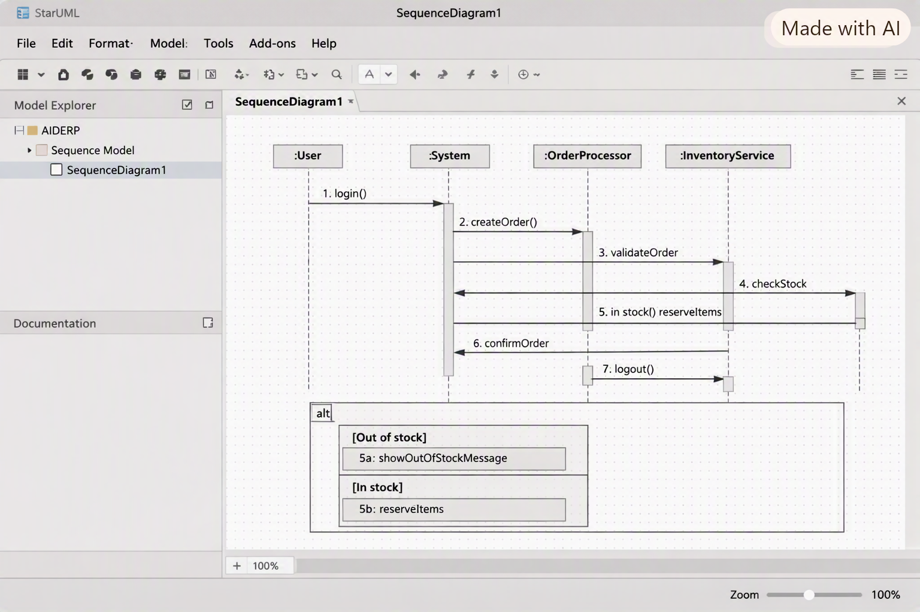
Figure 3: Sequence Diagram – Emergency Incident Reporting
Description: The Sequence Diagram illustrates the interaction between the Citizen, AIDERP application, Authentication Service, Incident Manager, Database and Risk Analysis Engine when an emergency is reported. It shows the sequence of messages exchanged from incident submission to risk analysis and operator notification.

3.4 Activity Diagram
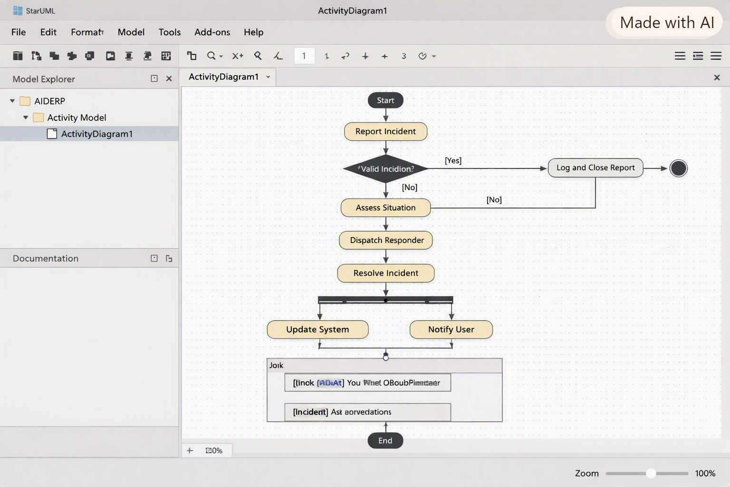
Figure 4: Activity Diagram – Emergency Response Workflow
Description: The Activity Diagram represents the workflow of an emergency from reporting to resolution. The process includes incident reporting, verification, risk analysis, prioritization, team assignment, responder acceptance, emergency response and incident resolution.

3.5 State Transition Diagram
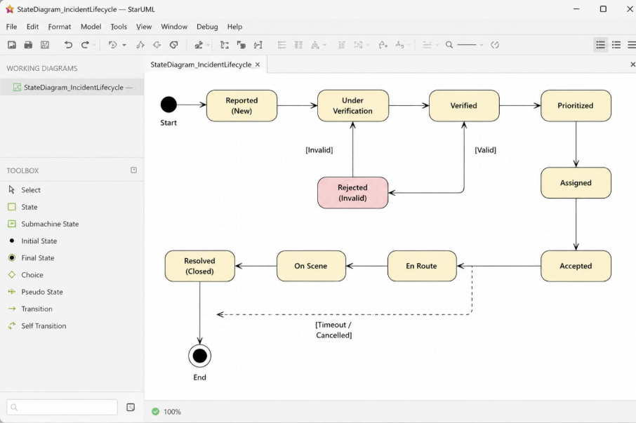
Figure 5: State Transition Diagram – Incident Lifecycle
Description: The State Transition Diagram represents the different states of an emergency incident. The incident progresses through states such as Reported, Under Verification, Verified, Prioritized, Assigned, Accepted, En Route, On Scene and Resolved. Invalid incidents may transition to the Rejected state.

3.6 Package Diagram
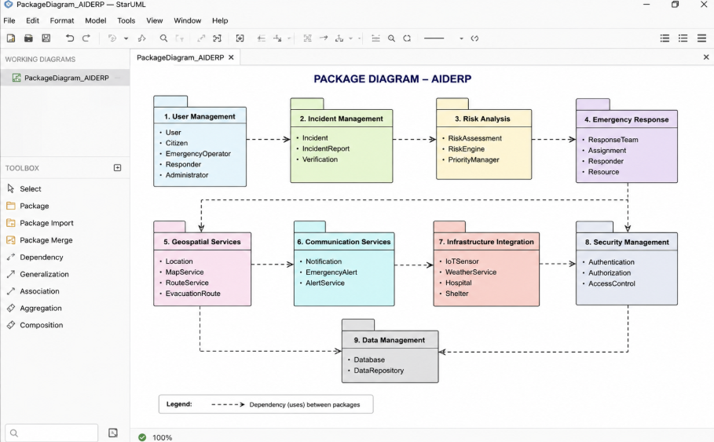
Figure 6: Package Diagram of AIDERP
Description: The Package Diagram divides the AIDERP system into logical modules such as User Management, Incident Management, Risk Analysis, Emergency Response, Geospatial Services, Communication, Infrastructure and Security. This modular organization improves maintainability and reduces unnecessary dependencies.

3.7 Component Diagram
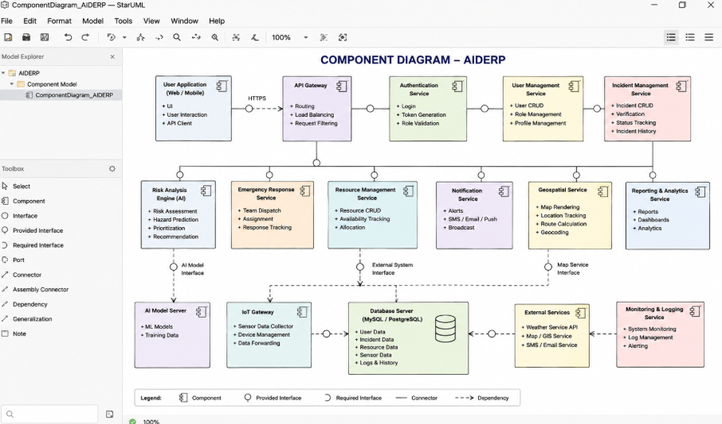
Figure 7: Component Diagram of AIDERP
Description: The Component Diagram represents the major software components of AIDERP and their dependencies. It includes the user application, authentication service, incident management service, risk-analysis engine, emergency response service, resource management, notification service, geospatial service, IoT gateway and database.

3.8 Deployment Diagram
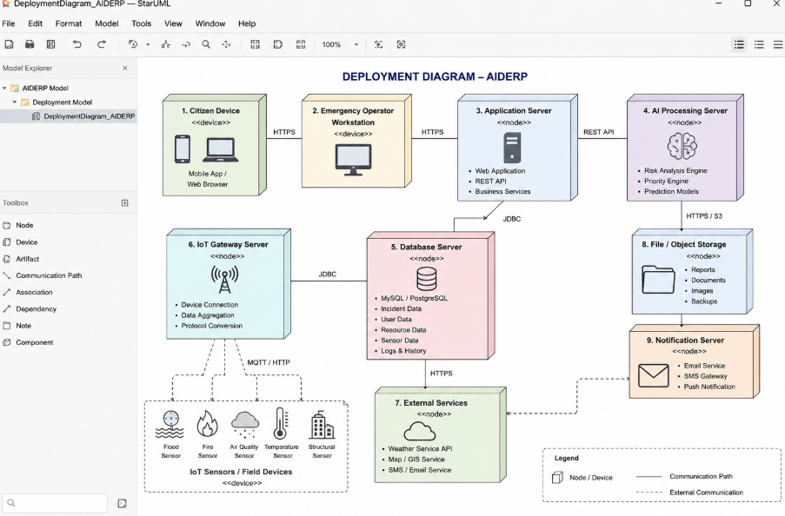
Figure 8: Deployment Diagram of AIDERP
Description: The Deployment Diagram represents the physical deployment of the AIDERP system. It includes citizen devices, emergency operator workstations, application servers, AI processing servers, database servers, IoT gateways and external services such as weather and geospatial services.
4. RESULTS AND VALIDATION
4.1 UML Design Results
The AIDERP system was modelled using UML diagrams to represent its functional, structural, behavioural, and architectural aspects. The developed Use Case, Class, Sequence, Activity, State Transition, Package, Component, and Deployment diagrams provide a complete view of the proposed disaster resilience and emergency response platform.
4.2 Functional Validation
The UML models were validated using the major emergency response scenarios:
- Citizen reports a flood or fire incident and requests assistance.
- Emergency operator verifies the reported incident.
- AI Risk Analysis Engine evaluates the severity and priority of the incident.
- Appropriate response teams and resources are assigned.
- Responders accept assignments and update their status.
- Citizens receive emergency alerts and evacuation guidance.
- Hospitals and shelters update their available capacity.
- IoT sensors provide preliminary information about abnormal conditions.
4.3 Consistency Validation
The diagrams were checked for consistency between structural and behavioural models. The classes and operations identified in the Class Diagram support the interactions shown in the Sequence and Activity Diagrams. The State Transition Diagram represents the complete lifecycle of an incident from Reported to Resolved. The Package, Component, and Deployment Diagrams provide the architectural organization required for modularity and scalability.
4.4 Expected Results
The proposed AIDERP design is expected to:
- Improve emergency incident reporting and verification.
- Support faster prioritization of critical incidents.
- Improve coordination between operators, responders, hospitals, shelters, and citizens.
- Provide location-based evacuation and routing support.
- Enable integration with IoT sensors and external weather services.
- Maintain secure and organized emergency information.
- Support scalable and maintainable system development.
4.5 Validation Outcome
The UML-based design satisfies the major functional and non-functional requirements identified for AIDERP. The models demonstrate appropriate use of object-oriented concepts such as encapsulation, abstraction, inheritance, polymorphism, cohesion, and controlled coupling. The design also supports security, privacy, fault tolerance, scalability, and graceful degradation.

5. RESULTS AND VALIDATION

5.1 Results
The AIDERP system was designed using Object-Oriented Analysis and Design principles and represented through UML models. The developed models describe the functional requirements, system structure, object interactions, behaviour, and deployment architecture of the proposed platform.
The following UML diagrams were developed:
- Use Case Diagram – represents interactions between users and the AIDERP system.
- Class Diagram – represents the major classes, attributes, methods, and relationships.
- Sequence Diagram – represents the interaction flow during emergency incident reporting.
- Activity Diagram – represents the overall emergency response workflow.
- State Transition Diagram – represents the lifecycle of an emergency incident.
- Package Diagram – represents the modular organization of the system.
- Component Diagram – represents the major software components and their dependencies.
- Deployment Diagram – represents the physical deployment of the proposed system.
These diagrams provide a complete conceptual representation of the AIDERP platform.

5.2 Functional Validation
The proposed design was validated against the major emergency scenarios identified in the assignment.
Test Scenario |  | Expected Result | Validation
Citizen reports an emergency |  | Incident is recorded in the system | Satisfied
Operator verifies an incident |  | Incident status changes after verification | Satisfied
AI analyses incident risk |  | Risk level and priority are generated | Satisfied
Response team is assigned |  | Suitable responder receives assignment | Satisfied
Responder updates status |  | Incident status changes during response | Satisfied
Citizen receives alert |  | Emergency notification is delivered | Satisfied
Shelter updates capacity |  | Available shelter capacity is updated | Satisfied
IoT sensor detects abnormal condition |  | Preliminary incident is generated | Satisfied

5.3 UML Model Validation
The UML models were checked for consistency and traceability. The classes and operations identified in the Class Diagram support the interactions represented in the Sequence Diagram. The Activity Diagram describes the workflow of emergency handling, while the State Transition Diagram represents the changing status of an incident.
The Package and Component Diagrams provide a modular representation of the system, and the Deployment Diagram shows how the major components can be deployed across devices, application servers, databases, AI processing servers, and external services.

5.4 Requirement Validation
The proposed design addresses the major requirements of the AIDERP platform, including:
- Emergency incident reporting.
- Incident verification and prioritization.
- AI-assisted risk analysis.
- Emergency team coordination.
- Resource management.
- Evacuation guidance.
- Shelter and hospital capacity management.
- IoT sensor integration.
- Geospatial services.
- Emergency notifications.
- Authentication and authorization.
- Secure information exchange.
- Scalable and maintainable architecture.
Therefore, the UML-based design provides a feasible conceptual solution for the identified disaster-response requirements.

6. ANALYSIS AND ENGINEERING DECISION

6.1 Analysis of the Proposed Solution
The AIDERP design combines object-oriented modelling with AI-assisted decision support, geospatial services, IoT integration, and emergency communication. This combination allows the system to handle different emergency activities through separate but interconnected modules.
The modular design improves maintainability because each major function can be developed and modified independently. For example, the Risk Analysis module can be improved without requiring a complete redesign of the User Management module.

6.2 Alternatives Considered
Two general approaches were considered for the system design:

Alternative 1: Monolithic Design
In a monolithic design, most system functions would be implemented as a single application.
Advantages:
- Simpler initial development.
- Easier to deploy for a small prototype.
Limitations:
- Difficult to maintain as the system grows.
- Failure of one major component may affect the complete system.
- Less flexible for integrating different technologies.

Alternative 2: Modular Object-Oriented Design
The proposed AIDERP design uses separate modules and components for different responsibilities.
Advantages:
- Better maintainability.
- Improved scalability.
- Easier integration of external services.
- Clear separation of responsibilities.
- Supports independent improvement of individual modules.
For these reasons, the modular object-oriented approach was selected.

6.3 Engineering Trade-Offs
The proposed system provides several benefits but also introduces certain trade-offs.
For example, integrating AI, IoT, geospatial services, and external communication services increases system functionality but also increases architectural complexity.
Similarly, real-time data improves emergency decision-making but requires reliable network connectivity and appropriate data-processing infrastructure.
Therefore, the design balances functionality and complexity by separating major responsibilities into independent modules.

6.4 Final Engineering Decision
The modular object-oriented architecture was selected because it provides a suitable balance between functionality, maintainability, scalability, security, and resilience.
The AI component is used as a decision-support mechanism rather than an autonomous decision-maker. Emergency operators remain responsible for validating incidents and making critical response decisions.
This approach provides greater control, accountability, and reliability for emergency response operations.

7. BROADER CONSIDERATIONS

7.1 Sustainability
AIDERP can support sustainable disaster management by improving the allocation and utilization of emergency resources. Proper assignment of response teams, vehicles, medical facilities, shelters, and other resources can reduce unnecessary resource usage.

7.2 Environment
The integration of IoT sensors and external weather services can help monitor environmental conditions such as floods, fires, temperature, and air quality.
Early identification of abnormal environmental conditions can support timely emergency response and reduce potential damage.

7.3 Society
AIDERP can improve communication between citizens and emergency authorities. Citizens can report incidents, request assistance, receive verified emergency alerts, locate shelters, and obtain evacuation guidance.
This can encourage community participation and improve coordination during disasters.

7.4 Safety
Safety is a major consideration in the proposed system. Incident verification, risk prioritization, responder tracking, emergency notifications, and safe-route recommendations are included to support safer emergency operations.
The system should clearly distinguish between verified and unverified information to reduce the possibility of misinformation and unnecessary panic.

7.5 Ethics
AI-generated recommendations should not be treated as unquestionable commands. Emergency operators should be able to review and validate important recommendations before taking critical actions.
The system should also minimize unnecessary collection of personal information and protect sensitive citizen and emergency data.

7.6 Economics
The modular architecture can reduce long-term maintenance costs because individual components can be modified or upgraded without redesigning the entire system.
Efficient resource allocation may also reduce unnecessary expenditure during emergency operations.

7.7 Accessibility
The system should provide a simple and accessible interface for citizens, emergency operators, and responders.
Emergency information should be presented clearly and through appropriate communication channels so that users can understand important instructions quickly.

7.8 Professional Responsibility
Developers have a professional responsibility to ensure that the system is reliable, secure, privacy-aware, and safe.
Since AIDERP is intended for emergency situations, proper testing, authentication, authorization, monitoring, fault tolerance, and responsible AI usage are important.

8. CONCLUSION
The AIDERP project proposes an AI-Enabled Disaster Resilience and Emergency Response Platform for supporting communities and emergency organizations during disasters such as floods, cyclones, fires, earthquakes, and heatwaves.
Object-Oriented Analysis and Design principles were applied to identify system actors, objects, classes, relationships, responsibilities, interactions, and architectural components.
Eight UML diagrams were developed to represent different aspects of the proposed system. The Use Case Diagram represents system functionality, the Class Diagram represents the static structure, and the Sequence and Activity Diagrams represent system behaviour. The State Transition Diagram represents the incident lifecycle, while the Package, Component, and Deployment Diagrams represent the modular and physical architecture.
The proposed solution addresses important requirements such as emergency reporting, incident verification, AI-assisted risk assessment, response-team coordination, resource management, evacuation guidance, IoT integration, geospatial services, and emergency notifications.
The major limitation is that the current work represents a conceptual design and UML-based solution rather than a fully deployed emergency platform. Real-world implementation would require reliable infrastructure, real-time data sources, extensive testing, secure communication, and validated AI models.
Future improvements can include real-time AI prediction, multilingual communication, advanced geospatial analysis, improved accessibility, stronger fault-tolerance mechanisms, and integration with additional emergency-management services.

9. STUDENT REFLECTION

9.1 Learning Beyond Classroom Knowledge
This assignment helped me understand how Object-Oriented Analysis and Design concepts can be applied to a complex real-world problem.
I learned how to analyse a problem statement and identify actors, objects, classes, attributes, methods, relationships, and responsibilities. I also gained a better understanding of how different UML diagrams represent different views of the same system.
The project improved my understanding of software architecture, modularity, scalability, security, and responsibility assignment.

9.2 Application of UML Concepts
Creating the UML models helped me understand the practical difference between structural and behavioural diagrams.
The Class Diagram helped me understand the static structure of the system, while the Sequence Diagram showed how objects communicate. The Activity Diagram helped represent the emergency workflow, and the State Transition Diagram helped represent changes in an incident's status.
The Package, Component, and Deployment Diagrams provided an understanding of how the system can be organized and deployed as a larger software solution.

9.3 Use of Modern Tools
UML modelling tools such as StarUML helped in representing the proposed system visually and organizing the different system components.
AI-assisted tools were also used during the preparation of ideas and documentation. However, the generated information was reviewed and adapted according to the AIDERP requirements.

9.4 Improvements with Additional Time and Resources
If additional time and resources were available, I would develop a working prototype of AIDERP with:
- Real-time emergency reporting.
- Live map and location tracking.
- IoT sensor integration.
- AI-based risk prediction.
- Real-time emergency notifications.
- Mobile application support.
- Multilingual communication.
- Role-based access control.
- Real-time hospital and shelter capacity updates.
- Performance and security testing.
These improvements would allow the proposed design to be tested under more realistic emergency conditions.

9.5 Overall Reflection
Overall, this assignment improved my ability to analyse a real-world problem and convert its requirements into an object-oriented software design.
It helped me understand that good software design is not only about functionality but also about security, safety, maintainability, scalability, accessibility, ethics, and professional responsibility.

10. REFERENCES
- SIMATS Engineering, Object Oriented Analysis and Design (CSA11) – Assignment Document.
- Object Management Group (OMG), Unified Modeling Language (UML) Specification.
- StarUML, UML Modeling Tool and Documentation.
- United Nations, Sustainable Development Goals (SDGs).
- PlantUML, UML Diagram Generation and Documentation.
- AI-assisted tools used during the preparation and refinement of the AIDERP UML models and documentation.

Required Deliverables
1. Problem Analysis and Requirement Summary
2. Functional and Non-Functional Requirements
3. Actor Identification
4. Use Case Descriptions
5. Use Case Diagram
6. Object and Class Identification
7. Class Diagram
8. Sequence/Interaction Diagram(s) for key emergency scenarios
9. Activity Diagram
10. State Transition Diagram
11. Package Diagram
12. Component Diagram
13. Deployment Diagram
14. Object Responsibility Analysis
15. Design Axioms/Principles and Design Pattern Justification
16. Assumptions, Constraints, Security and Privacy Considerations
17. Requirement-to-Use Case/Class Traceability Matrix
18. Implementation/Prototype and Results
19. Reflection on Design Decisions, SDG Relevance and Learning Outcomes
20. GitHub Upload

Suggested Key Scenarios for UML Modelling
- Citizen reports a flood/fire emergency and requests assistance.
- AI risk engine prioritizes incidents and recommends response resources.
- Emergency operator verifies an incident and dispatches a response team.
- Responder accepts an assignment and updates the incident status from En Route to Resolved.
- Citizen receives an evacuation alert and obtains a recommended safe route to a shelter.
- Hospital or shelter updates available capacity during a large-scale emergency.
- IoT sensor detects abnormal conditions and automatically creates a preliminary incident.

Assessment Rubric
Assessment Criterion | Marks | Expected Evidence
Problem Understanding, Object Identification & Requirements Analysis (CO1) | 10 | Accurate actors, objects, responsibilities and functional/non-functional requirements.
Use Case Modelling & Actor Identification (CO2) | 10 | Complete system boundary, actors, use cases and logical relationships.
Class Identification, Attributes, Methods & Relationships (CO2/CO3) | 15 | Accurate classes, attributes, methods, associations, aggregation/composition, inheritance and dependencies.
UML Behavioural & Interaction Modelling (CO2) | 15 | Consistent Sequence, Activity and State Transition Diagrams.
UML Architectural Modelling & Design Evaluation (CO3) | 15 | Clear Package, Component and Deployment Diagrams.
Object Responsibilities, Design Principles, Axioms & Patterns (CO3) | 15 | Well-assigned responsibilities and justified OO principles/patterns.
Consistency, Traceability & Overall Design Quality (CO3) | 10 | Mutual consistency, requirement traceability, resilience, security, scalability and maintainability.
Reflection, SDG Relevance & Learning Outcomes | 10 | Insightful reflection, design decisions and meaningful SDG linkage.
TOTAL | 100

CO–PO–Assessment Mapping
Assessment Component | CO | PO(s) | Bloom's Level
Problem formulation | CO1 | PO1, PO2 | L3/L4
Application of knowledge | CO1/CO2 | PO1, PO2, PO3 | L3/L4
Solution / Design / Implementation | CO2/CO3 | PO3, PO5 | L4/L5/L6
Modern tool usage | CO2 | PO5 | L3/L4
Validation | CO3 | PO2, PO4 | L4/L5
Analysis & justification | CO3 | PO2, PO3 | L4/L5
Broader considerations | CO3 | PO6, PO7 | L4/L5
Documentation & reflection | CO1/CO3 | PO9, PO10 | L3/L4
Note: The PO mapping should be finalized by the faculty based on the programme's approved PO definitions and the components genuinely assessed.

Faculty Evaluation & Continuous Improvement
Target CO Attainment | ____________________________
Actual CO Attainment | ____________________________
Areas in which students performed well | ____________________________________________________________
Areas requiring improvement | ____________________________________________________________
Corrective / Improvement Action | ____________________________________________________________
Action to be implemented in the next offering | ____________________________________________________________

Documents to Be Maintained
1. Assignment question/problem statement
2. CO–PO and Bloom's mapping
3. Assessment rubric
4. Student submissions
5. Tool/simulation/experimental evidence, where applicable
6. Evaluated scripts/reports
7. Marks and rubric-wise assessment
8. CO attainment analysis
9. Sample student work representing different performance levels
10. Faculty analysis and continuous-improvement action

